Written by Tiffany Floyd

**Hikmet, Mohammed Ghani** (1929-2011)

349 words

Mohammed Ghani Hikmet is considered Iraq’s most prolific and influential modern sculptor. After graduating from the Institute of Fine Arts in Baghdad in 1953, Hikmet travelled to Rome to attend the *Accademia di Belle Arti*. While in Italy, he also studied bronze casting at the *Instituto di Zaka* in Florence. After returning to Baghdad, Hikmet taught at the Institute of Fine Arts and the College of Architectural Engineering at the University of Baghdad. He also became involved in several Baghdadi art groups, most notably the Baghdad Group of Modern Art. Hikmet is best known for his monumental sculptures that dot the cityscape of Baghdad. Many of his works, like *The Fountain of Kahramana* and *Scheherazade and Shahrayar* (1917), have become emblematic of Iraq itself. Hikmet also assisted in the creation of two major public works begun under other prominent Iraqi sculptors. He oversaw the casting of Jewad Selim’s massive figures for the *Monument to Freedom*. Following Selim’s premature death in 1961, Hikmat supervised its completion. Similarly, upon the death of the sculptor Khalid al-Rahal in 1987, Hikmet had to finish the work on the contested *Arch of Victory*.

In the wake of the 2003 US led invasion of Iraq, Hikmet became a major advocate for the recovery of artworks looted from the National Museum of Modern Art in Baghdad. As part of this effort, he formed the Committee for Recovering Iraq’s Culture, which was able to reclaim at least 100 artworks. Born in Baghdad, Iraq, Hikmat relocated to Amman, Jordan soon after the 2003 invasion. He died in Bahrain following a massive heart attack in 2011.

**Resources and further reading:**

Aziz, Barbara Nimri. “Notes from Iraq: Barbara Nimri Aziz remembers sculptor Mohammed Ghani Hikmat.” AhramOnline. September 21, 2011. <http://english.ahram.org.eg/NewsContent/5/25/21999/Arts--Culture/Visual-Art/Notes-from-Iraq-Barbara-Nimri-Aziz-remembers-sculp.aspx>

Bahrani, Zainab and Nada Shabout. *Modernism and Iraq*. New York: Miriam and Ira D. Wallach

Art Gallery, Columbia University Press, 2009.

“Mohammed Ghani Hikmat.” YouTube.com. Last Modified December 6th, 2007. <http://www.youtube.com/watch?v=vJ405x0P0hQ>

Schmidt, Michael S. “Mohammed Ghani Hikmat, Iraqi Sculptor, Dies at 82,” *New York Times*.

September 21, 2011. <http://www.nytimes.com/2011/09/21/arts/design/mohammed-ghani-hikmat-iraqi-sculptor-dies-at-82.html>

Shabout, Nada. *Sajjil: A Century of Modern Art*. Doha: Arab Museum of Modern Art, Qatar

Museum Authority, 2010.

____________. “Farewell Mohammed Ghani Hikmat.” *Jadaliyya*. September 13, 2011.

<http://www.jadaliyya.com/pages/index/2641/farewell-mohammad-ghani-hikmat>.

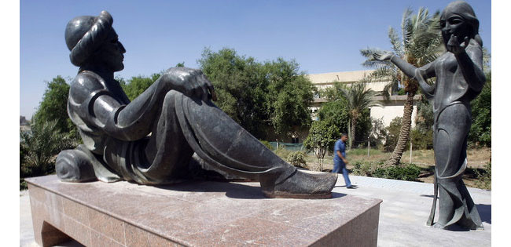

Mohammed Ghani Hikmat

*Scheherazade and Shahrayar* (1971)

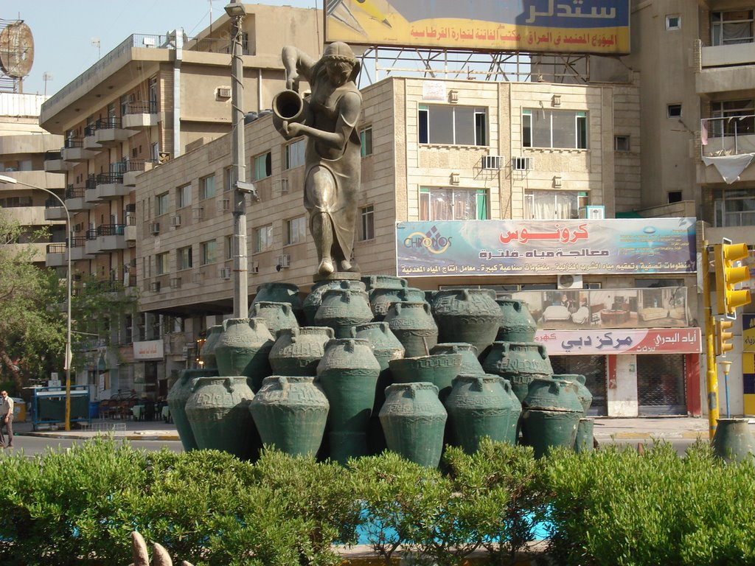Mohammed Ghani Hikmat

*The Fountain of Kahramana*